Data Structures and Algorithm using Python

Program 1:

Aim:

Write Python Program to Perform Linear Search using Recursion to find the element is found or not and its position.

Algorithm:

Step 1: Start

Step 2: Read list elements from the user and store them in list L1

Step 3: Read the element to be searched and store it in x

Step 4: Initialize pointer i = 0

Step 5: Repeat while i < len(L1)
Step 5.1: If L1[i] == x, then
Print “Element x present at ith position”
Exit the loop

Step 5.2: Otherwise, increment i by 1

Step 6: After the loop, check if i >= len(L1)

Step 7: If true, print “Element is not present”

Step 8: Stop

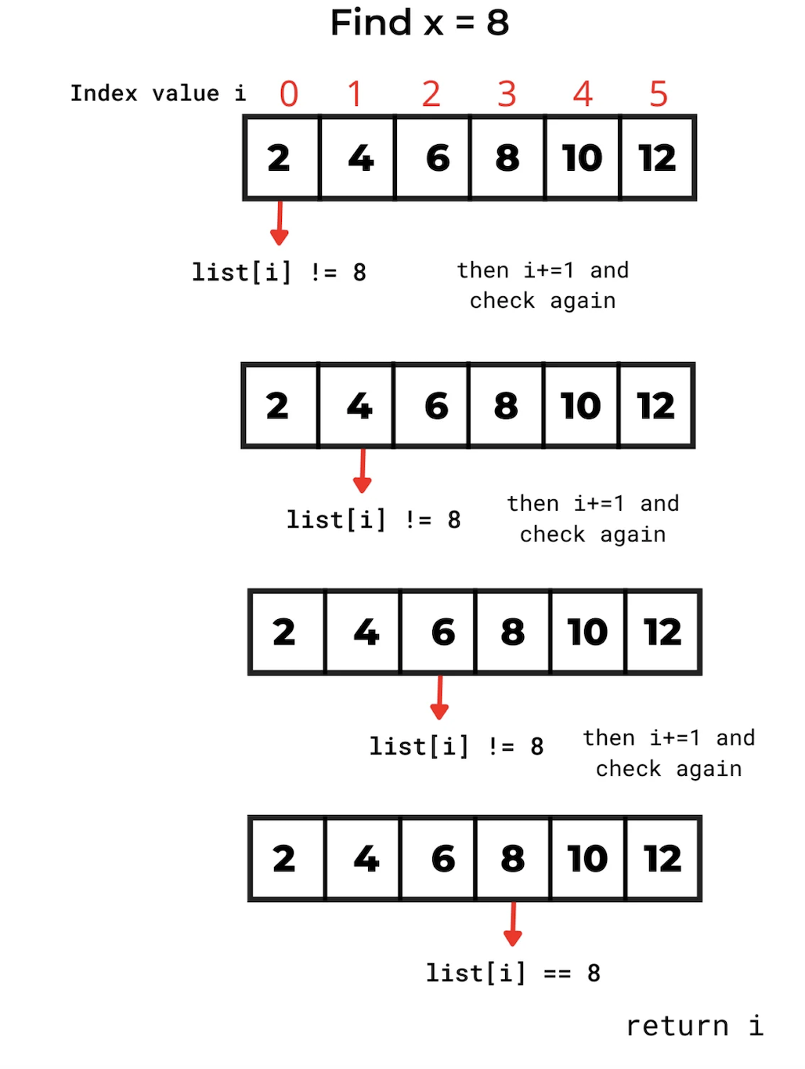

Program:

# Taking list input from user
L1 = list(map(int, input("Enter list elements separated by space: ").split()))

# Taking element to search
x = int(input("Enter element to search: "))

i = 0 # pointer

while i < len(L1):
if L1[i] == x:
print(f'Element {x} present at {i}th position')
break
i += 1

if i >= len(L1):
print('Element is not present')

Output:

Enter list elements separated by space: 2 10 30 40 50

Enter element to search: 30

Element 30 present at 2th position

Result:

The Python program to perform linear search using recursion to determine whether an element is found and to display its position was successfully executed.

-----------------------------------------------------------------------------------------------

Program 2:

Aim:

Write Python Program to Perform Binary Search using Recursion using an array to find the position of an element in an index.

Algorithm:

Step 1: Start

Step 2: Define a function binary_search(arr, low, high, x)

Step 3: Check if high ≥ low

Step 4: If true, calculate the middle index mid = (low + high) // 2

Step 5: Compare arr[mid] with x

Step 5.1: If arr[mid] == x, return mid
Step 5.2: Else if arr[mid] > x, call binary_search(arr, low, mid − 1, x)

Step 5.3: Else, call binary_search(arr, mid + 1, high, x)

Step 6: If high < low, return -1 (element not present)

Step 7: Read sorted array elements from the user and store in array arr

Step 8: Read the element to be searched and store it in x

Step 9: Call result = binary_search(arr, 0, length of arr − 1, x)

Step 10: If result ≠ -1, print “Element x is present at index result”

Step 11: Else, print “Element is not present in array”

Step 12: Stop

Program:

# Returns index of x in arr if present, else -1
def binary_search(arr, low, high, x):

# Check base case
if high >= low:
mid = (high + low) // 2

# If element is present at the middle itself
if arr[mid] == x:
return mid

# If element is smaller than mid, search left subarray
elif arr[mid] > x:
return binary_search(arr, low, mid - 1, x)

# Else search right subarray
else:
return binary_search(arr, mid + 1, high, x)
else:
return -1

# Taking sorted array input at runtime
arr = list(map(int, input("Enter sorted array elements separated by space: ").split()))

# Taking element to search
x = int(input("Enter element to search: "))

# Function call
result = binary_search(arr, 0, len(arr) - 1, x)

if result != -1:
print(f"Element {x} is present at index {result}")
else:
print("Element is not present in array")

Output:

Enter sorted array elements separated by space: 10 20 30 40 50 60 70

Enter element to search: 50

Element 50 is present at index 4

Result:

The Python program to perform binary search using recursion on an array to find the position of an element was successfully executed.

-----------------------------------------------------------------------------------------------

Program 3:

Aim:

Write a Python program to perform stack operations like push, pop, and display using a list.

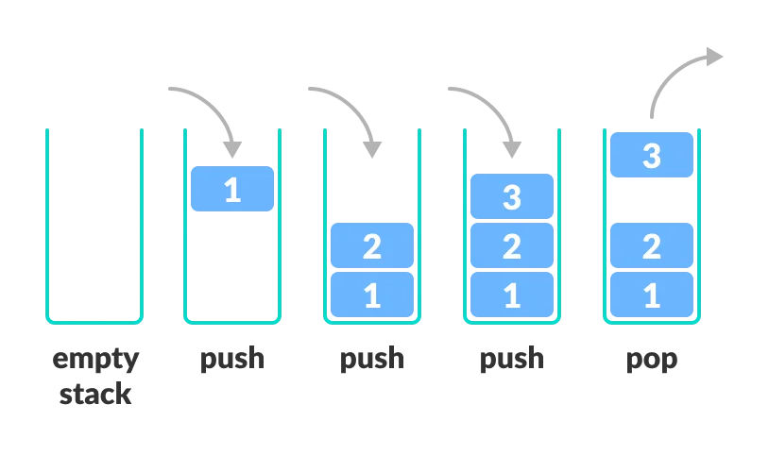
Algorithm:

Step 1: Start

Step 2: Declare an empty list named stack

Step 3: Define a function add() to push an element into the stack
- Step 3.1: Read an item from the user
- Step 3.2: Check if the item already exists in the stack
- Step 3.3: If it exists, display “The item already exists”
- Step 3.4: Else, append the item to the stack and display “Item inserted”

Step 4: Define a function remove() to pop an element from the stack
- Step 4.1: Check whether the stack is empty
- Step 4.2: If empty, display “Stack is empty”
- Step 4.3: Else, remove the last element using pop() and display it

Step 5: Define a function display() to show all elements of the stack
- Step 5.1: Check whether the stack is empty
- Step 5.2: If empty, display “Stack is empty”
- Step 5.3: Else, display all elements of the stack

Step 6: Define a function repeat() to perform menu-driven stack operations
- Step 6.1: Display menu options (a - Add, r - Remove, d - Display, c - Continue, e - Exit)
- Step 6.2: Read the user’s choice
- Step 6.3: If choice is 'a', call add()
- Step 6.4: If choice is 'r', call remove()
- Step 6.5: If choice is 'd', call display()
- Step 6.6: If choice is 'c', call repeat() to continue menu
- Step 6.7: If choice is 'e', stop the stack operation
- Step 6.8: If choice is invalid, display “INVALID OPTION”
- Step 6.9: Repeat until the user chooses 'e'

Step 7: Call the repeat() function to start the program

Step 8: Stop

Program:

# Stack Declaration
stack = []

def add():
item = input("Enter your item: ")
if item in stack:
print("The item already exists")
else:
stack.append(item)
print("Item inserted:", item)

def remove():
if not stack:
print("Stack is empty")
else:
e = stack.pop()
print("Item removed:", e)

def display():
if not stack:
print("Stack is empty")
else:
print("Current Stack:", stack)

def repeat():
while True:
user = input(
"\na - Add element\n"
"r - Remove element\n"
"d - Display stack\n"
"c - Continue\n"
"e - Exit\n"
"\n"
"Enter your choice: "
)

if user == "a":
add()
elif user == "r":
remove()
elif user == "d":
display()
elif user == "c":
repeat()
elif user == "e":
print("The stack operation is stopped!")
break
else:
print("INVALID OPTION")

# Main Program
repeat()

Output:

a - Add element
r - Remove element
d - Display stack
c - Continue
e - Exit

Enter your choice: a
Enter your item: 5
Item inserted: 5

a - Add element
r - Remove element
d - Display stack
c - Continue
e - Exit

Enter your choice: d
Current Stack: ['5']

a - Add element
r - Remove element
d - Display stack
c - Continue
e - Exit

Enter your choice: r
Item removed: 5

a - Add element
r - Remove element
d - Display stack
c - Continue
e - Exit

Enter your choice: d
Stack is empty

a - Add element
r - Remove element
d - Display stack
c - Continue
e - Exit

Enter your choice: e
The stack operation is stopped!

Result:

The Python program to perform stack operations (push, pop, and display) using a list was executed successfully.

------------------------------------------------------------------------------------------------

Program 4:

Aim:

Write a Python program to perform Queue operations like push, pop, and display using a list.

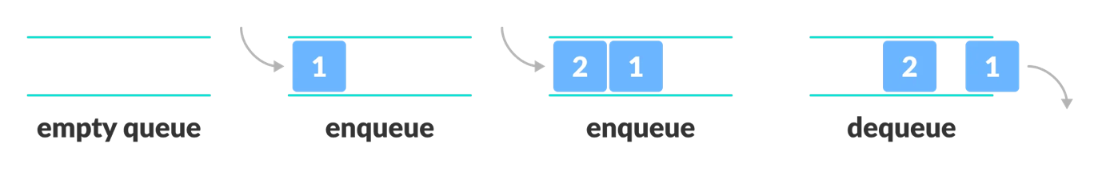
Algorithm:

Step 1: Start

Step 2: Declare an empty list named queue

Step 3: Define a function add() to insert an element into the queue

Step 4: In add(), read an item from the user

Step 5: Check whether the item already exists in the queue
Step 5.1: If the item exists, display “The item already exists”
Step 5.2: Else, append the item to the queue and display “Item inserted”

Step 6: Define a function remove() to delete an element from the queue

Step 7: In remove(), check whether the queue is empty
Step 7.1: If the queue is empty, display “Queue is empty”
Step 7.2: Else, remove the first element using pop(0) and display the removed item

Step 8: Define a function display() to show queue elements

Step 9: In display(), check whether the queue is empty
Step 9.1: If empty, display “Queue is empty”
Step 9.2: Else, display all elements of the queue

Step 10: Define a function repeat() to perform menu-driven operations

Step 11: Display the menu options (add, remove, display, continue, exit)

Step 12: Read the user’s choice
Step 12.1: If choice is 'a', call add()
Step 12.2: If choice is 'r', call remove()
Step 12.3: If choice is 'd', call display()
Step 12.4: If choice is 'c', continue queue operations
Step 12.5: If choice is 'e', stop the queue operation
Step 12.6: Else, display “Invalid Option”

Step 13: Repeat the above steps until the user chooses exit

Step 14: Stop

Program:

# Queue Declaration
queue = []

# Function to add an element in queue
def add():
item = input("Enter your item: ")
if item in queue:
print("The item already exists")
else:
queue.append(item)
print("Item inserted:", item)

# Function to remove an element in queue
def remove():
if not queue:
print("Queue is empty")
else:
e = queue.pop(0)
print("Item removed:", e)

# Function to display all element in queue
def display():
if not queue:
print("Queue is empty")
else:
print("Current Queue:", queue)

# Function to get choice from user to perform operation in queue
def repeat():
while True:
user = input(
"\na - Add element\n"
"r - Remove element\n"
"d - Display queue\n"
"c - Continue\n"
"e - Exit\n"
"\n"
"Enter your choice: "
)

if user == "a":
add()
elif user == "r":
remove()
elif user == "d":
display()
elif user == "c":
repeat()
elif user == "e":
print("Queue operation stopped")
break
else:
print("INVALID OPTION")

# Main Program
repeat()

Output:

a - Add element
r - Remove element
d - Display queue
c - Continue
e - Exit

Enter your choice: a
Enter your item: 5
Item inserted: 5

a - Add element
r - Remove element
d - Display queue
c - Continue
e - Exit

Enter your choice: d
Current Queue: ['5', '6']

a - Add element
r - Remove element
d - Display queue
c - Continue
e - Exit

Enter your choice: r
Item removed: 5

a - Add element
r - Remove element
d - Display queue
c - Continue
e - Exit

Enter your choice: d
Current Queue: []

a - Add element
r - Remove element
d - Display queue
c - Continue
e - Exit

Enter your choice: e
Queue operation stopped

Result:

The Python program to perform Queue operations (push, pop, and display) using a list was executed successfully.

------------------------------------------------------------------------------------------------

